SIMATS ENGINEERING (SAVEETHA SCHOOL OF ENGINEERING)
Department of Computer Science and Engineering
CO2_AT1 — CHART CONSTRUCTION TEST

Course Code: | DSA06 | Course Title: | Data Handling and Visualization
CO Assessed: | CO2 – Construction (BL3) | Assessment: | Assessment Tool 1 – Chart Construction
Weightage: | 20% of CIA | Total Marks: | 25 (5 Questions × 5 Marks)
CO2 Statement: | Apply appropriate chart construction techniques — correct chart type, axes, scales, and calculations — to accurately represent given data.(BL3)
Student Name: | K. Amrutha Sandhya | Reg. No.: | 192524270
Section / Batch: | AIDS | Date: | 30-07-2026

Code of Conduct
I ___ K. Amrutha Sandhya (192524270)(Name / Reg No) certify that this submission is my original work and that I have adhered to the guidelines specified for this assessment. I understand that any violation of academic integrity rules will result in disciplinary action.

Signature of the Student: Amrutha

Instructions
- This test contains 5 questions, each carrying 5 marks. Total: 25 Marks.
- No negative marking. Unanswered questions carry zero marks.
- No calculators or electronic devices permitted.
- Duration: 75 minutes.
- Graph paper or a ruler is recommended for accurate, to-scale drawing.
- Show all calculations (e.g., percentages, angles, bin ranges, five-number summaries) as part of your answer.
- Every chart must include a title, correctly labeled axes, and a legend where applicable.

Annexure A – CHART CONSTRUCTION

Rubrics for Calculation ASSESSMENT RUBRIC
AT1 — Chart Construction Test
CO2 · BT3: Apply ·
This rubric is used to assess student responses to the CO2-AT1 Chart Construction Test, in which students are given a small dataset and must construct an accurate, correctly labeled chart of a specified type.

Criteria | Weightage | Level 4 – Exemplary | Level 3 – Proficient | Level 2 – Developing | Level 1 – Beginning
Understanding of Concepts | 25% | Demonstrates thorough, accurate understanding of the correct chart type, and the axes, scale, and elements required to construct it for the given data. | Good understanding of the required chart type and construction elements, with only minor gaps. | Basic understanding of chart construction, but with some misconceptions about the correct chart type, axes, or scale. | Poor understanding of core construction concepts; selects a chart type or elements fundamentally unsuited to the data.
Explanation | 25% | Shows detailed, clearly worked calculations (e.g., angles, bin ranges, five-number summary) and explains each construction step. | Shows clear calculations and construction steps, with adequate explanation for most parts. | Calculations or construction steps are shown but incomplete, or explanations are superficial. | Little or no working shown; calculations and construction steps are missing or unexplained.
Application | 20% | Effectively applies chart construction techniques to produce a complete, accurate chart correctly matched to the data. | Applies construction techniques to produce a correct chart, with only minor errors. | Limited application of construction techniques; the chart partially represents the data but has notable errors. | Fails to apply appropriate construction techniques; the chart does not correctly represent the data.
Organization | 15% | The chart is neatly and logically constructed, with a title, correctly labeled axes, a legend where applicable, and elements in a clear order. | The chart is well organized, with only minor issues in labeling, legend, or layout. | Basic construction; required elements (title, axes, legend) are present but poorly arranged or partly missing. | Poorly constructed; the chart is missing key elements such as a title, axis labels, or a legend.
Accuracy | 10% | The chart is completely accurate — all values, proportions, scales, and calculations correctly match the given data. | Mostly accurate, with only minor omissions or a small error in one value or calculation. | Partially correct; some plotted values, proportions, or calculations are missing or incorrect. | Largely inaccurate; major errors in plotted values, proportions, or calculations relative to the given data.

Scoring Guide
For each criterion, award a performance level (1–4) based on the descriptors above. Multiply the level achieved (as a percentage of 4, i.e., Level 4 = 100%, Level 3 = 75%, Level 2 = 50%, Level 1 = 25%) by the criterion's weightage, then sum across all five criteria to obtain the total score out of 100%.

Faculty In-charge | Course Coordinator | Head of Department
Signature: _______________ | Signature: _______________ | Signature: _______________
Date: ___________________ | Date: ___________________ | Date: ___________________

Problem 1 — Bar Chart — Basic Construction
Data: Monthly sales (units): Jan = 120, Feb = 150, Mar = 90, Apr = 200, May = 175. Task: Construct a bar chart to represent monthly sales. Label both axes, include a chart title, and keep the months in chronological order.
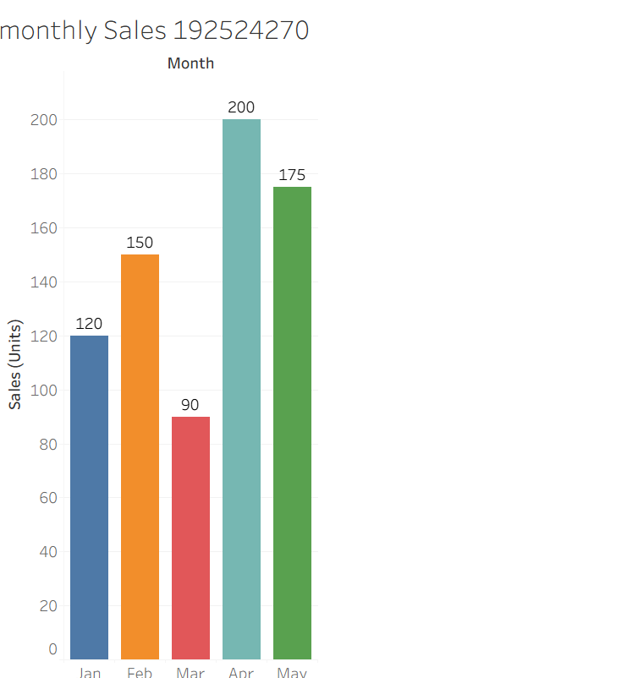

Problem 22 — Diverging Color Scale — Profit/Loss
Data: Monthly profit/loss ($'000): Jan=−15, Feb=+8, Mar=−3, Apr=+22, May=+5, Jun=−10.
Task: Construct a bar chart using a diverging color scale (e.g., one color for loss, another for profit) to represent this data, clearly marking the zero baseline.
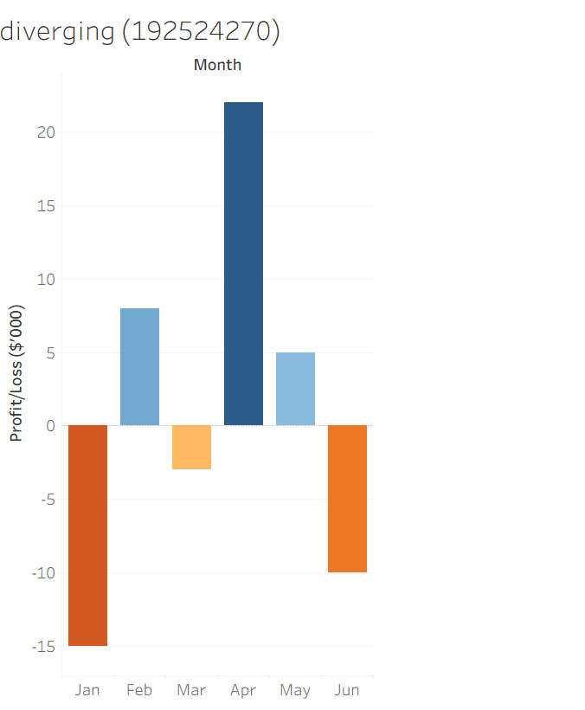

Problem 23 — Treemap — Proportional Area
Data: Revenue by product category: Electronics=$400K, Clothing=$250K, Books=$150K, Toys=$100K,
Home=$100K.
Task: Construct a treemap where each rectangle's area is proportional to that category's share of total revenue. Show your calculation of each category's percentage share.
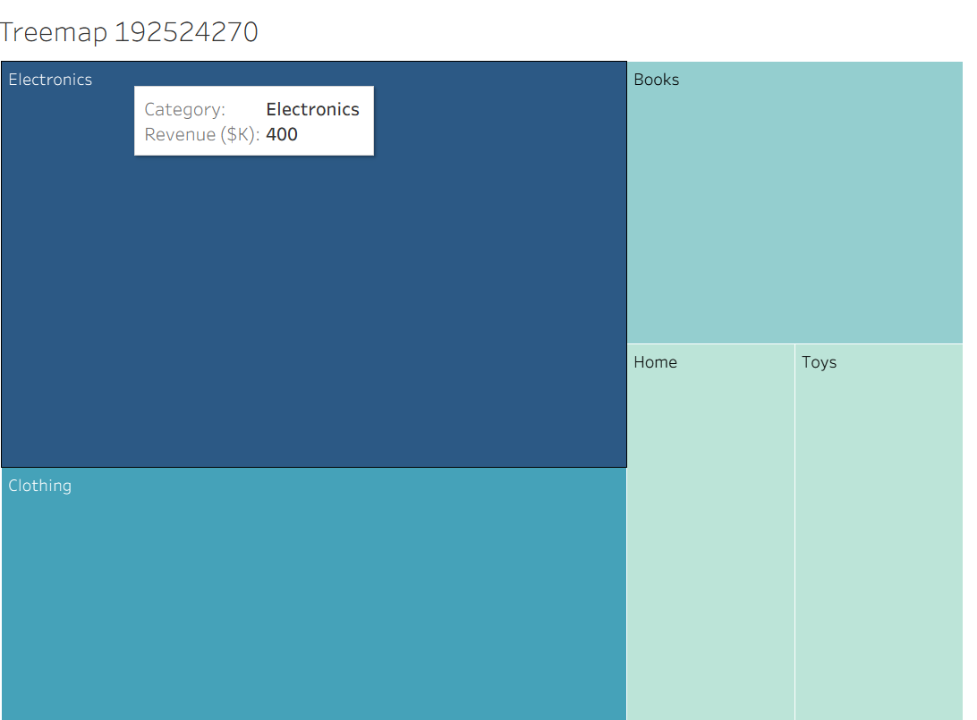

Problem 24 — Combination Chart — Bar + Line
Data: Monthly sales (units) and average price ($): Jan=(100,20), Feb=(120,22), Mar=(90,25), Apr=(150,21), May=(130,23), Jun=(160,24).
Task: Construct a chart combining a bar chart (units sold) with a line chart (average price) across the six months. Explain why you would avoid using a dual y-axis and how you would represent both variables
clearly instead.

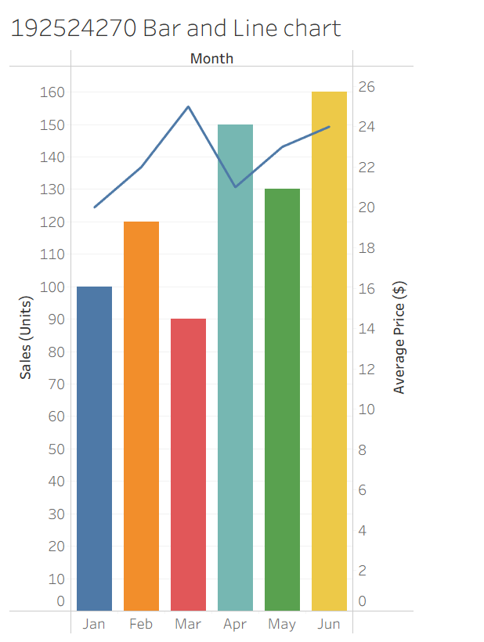
Problem 25 — Small Multiples Construction
Data: Weekly sales (units) for 4 regions over 4 weeks: Region A: 40, 55, 50, 65 Region B: 30, 35, 45, 40 Region C: 60, 58, 70, 75 Region D: 20, 25, 22, 30
Task: Construct a set of four small-multiple line charts, one per region (rather than one overlaid chart), and briefly justify this design choice over a single combined chart.
